Tutorial #3: More Search (the Sequel)
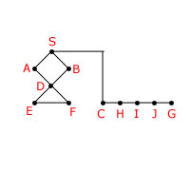
We are trying to find a path from S to G in the following graph:
Connections (all undirected):
S: A B C F: D E
A: S D G: J
B: S D H: C I
C: S H I: H J
D: A B E F J: I G
E: D F
The path length of all the links is 1, except for S-C which is of length 10.
The heuristic distance estimates to the goal are:
S = 10, A = 5, B = 11, C = 1, D = 7, E = 6,
F = 5, H = 3, I = 2, J = 1, G = 0
Assume that the implementation of Uniform Cost Search and A* places newly extended paths at the front of Q, with the new paths ordered by alphabetical order of the head state. The order on Q of paths will be used to resolve any ties in choosing the "best" path to pull off of Q, the path that appears closer to the front of Q is chosen.
Write the sequence of states expanded by the specified search methods in our implementation. In some searches states may be repeated in the sequence. When using an expanded list, if the state pulled off Q is found in the expanded list, you should not include it in your answer (since its descendants are not generated). You will save yourself a LOT of confusion if you first convert the graph above into the appropriate search tree.
- Uniform Cost (NOT using Expanded List). This is tricky, please pay careful attention to the rule for settling ties given above. In each slot, enter a state name, including S and G:
- Uniform Cost (using strict Expanded List). In each slot, enter a state name, including S and G:

- A* (using strict Expanded List). For this answer, enter into each box both the state and the value of the f-value for the corresponding node. For example - S 10:

